IOE AND AI DRIVEN SYSTEMS
EXPERIMENT 6 :
PROGRAM CODE:
import numpy as np
import pandas as pd
import matplotlib.pyplot as plt
# Set random seed for reproducibility
np.random.seed(42)
print("="*85)
print("PART 1: PEOPLE-PROCESS-DATA-THINGS (P-P-D-T) IoE & EDGE/FOG/CLOUD SIMULATION (WITH MQTT)")
print("="*85)
# 1. P-P-D-T Data Flow Simulation across Tiers (Edge, Fog, Cloud) including MQTT messaging
ppdt_components = [
"Things (Sensors/Actuators + MQTT)",
"People (User Wearables/UI + MQTT)",
"Process (Node-RED/Rules)",
"Data (Aggregated Store)"
]
tiers = ["Edge Layer", "Fog Layer", "Cloud Layer"]
ppdt_results = []
for comp in ppdt_components:
for tier in tiers:
# Simulate realistic latency, bandwidth usage, and packet loss based on tier proximity & MQTT behavior
if tier == "Edge Layer":
latency = np.random.uniform(2.0, 5.0)
throughput = np.random.uniform(50.0, 100.0)
reliability = np.random.uniform(99.0, 99.9)
elif tier == "Fog Layer":
latency = np.random.uniform(10.0, 25.0)
throughput = np.random.uniform(200.0, 500.0)
reliability = np.random.uniform(98.0, 99.5)
else: # Cloud Layer
latency = np.random.uniform(50.0, 120.0)
throughput = np.random.uniform(1000.0, 2500.0)
reliability = np.random.uniform(97.0, 99.0)
ppdt_results.append([comp, tier, round(latency, 2), round(throughput, 2), round(reliability, 2)])
df_ppdt = pd.DataFrame(ppdt_results, columns=["IoE Component (P-P-D-T + MQTT)", "Pipeline Tier", "Avg Latency (ms)", "Throughput (kbps)", "Reliability (%)"])
print(df_ppdt.head(12).to_string(index=False))
print("\n" + "="*85)
print("PART 2: 5G vs 6G COMMUNICATION BENCHMARKING FOR IoE")
print("="*85)
# 2. 5G vs 6G Benchmarking
technologies = ["5G Ultra-Reliable Low-Latency (URLLC)", "6G Terahertz (THz) Communication"]
benchmark_data = {
"5G URLLC": {"Throughput": 10000, "Latency": 4.5, "Reliability": 99.99, "Energy": 12.0},
"6G THz": {"Throughput": 100000, "Latency": 0.5, "Reliability": 99.999, "Energy": 4.5}
}
bench_results = []
for tech in technologies:
key = "5G URLLC" if "5G" in tech else "6G THz"
b = benchmark_data[key]
# Add small statistical variations
throughput = max(100, b["Throughput"] + np.random.normal(0, b["Throughput"] * 0.02))
latency = max(0.1, b["Latency"] + np.random.normal(0, 0.1))
reliability = min(100.0, b["Reliability"] + np.random.normal(0, 0.001))
energy = max(0.5, b["Energy"] + np.random.normal(0, 0.5))
bench_results.append([tech, round(throughput, 2), round(latency, 2), round(reliability, 3), round(energy, 2)])
df_bench = pd.DataFrame(bench_results, columns=["Communication Tech", "Throughput (Mbps)", "Latency (ms)", "Reliability (%)", "Energy Consumption (mJ/bit)"])
print(df_bench.to_string(index=False))
print("\n" + "="*85)
print("GENERATING BENCHMARKING & PIPELINE GRAPHS...")
print("="*85)
# 3. Visualizations
# Graph 1: Edge/Fog/Cloud Latency across P-P-D-T components (including MQTT)
plt.figure(figsize=(11, 5))
for tier in tiers:
subset = df_ppdt[df_ppdt["Pipeline Tier"] == tier]
plt.plot(subset["IoE Component (P-P-D-T + MQTT)"], subset["Avg Latency (ms)"], marker='o', linewidth=2, label=tier)
plt.title("Edge / Fog / Cloud Pipeline Latency for P-P-D-T & MQTT Components")
plt.xlabel("IoE Components (P-P-D-T + MQTT)")
plt.ylabel("Latency (ms)")
plt.xticks(rotation=10)
plt.legend()
plt.grid(True, alpha=0.3)
plt.tight_layout()
plt.show()

# Graph 2: 5G vs 6G Comparison Bar Charts
metrics = [
("Throughput (Mbps)", "Throughput Comparison: 5G vs 6G", "Throughput (Mbps)"),
("Latency (ms)", "Latency Comparison: 5G vs 6G", "Latency (ms)"),
("Reliability (%)", "Reliability Comparison: 5G vs 6G", "Reliability (%)"),
("Energy Consumption (mJ/bit)", "Energy Efficiency Comparison: 5G vs 6G", "Energy (mJ/bit)")
]
for col, title, ylabel in metrics:
plt.figure(figsize=(7, 4))
bars = plt.bar(df_bench["Communication Tech"], df_bench[col], color=["#3498db", "#2ecc71"])
plt.title(title)
plt.ylabel(ylabel)
plt.grid(axis="y", alpha=0.3)
plt.tight_layout()
plt.show()
print("\n" + "="*85)
print("CONCLUSION & SUMMARY")
print("="*85)
print("1. Edge/Fog pipeline integrated with lightweight MQTT messaging minimizes local processing delay for Things and People components.")
print("2. Cloud layer handles heavier aggregated P-P-D-T data storage with higher latency.")
print("3. 6G significantly outperforms 5G in throughput, ultra-low latency (<1ms), and energy efficiency,")
print(" making it optimal for massive next-generation IoE deployments.")

OUTPUT:
PART 1: PEOPLE-PROCESS-DATA-THINGS (P-P-D-T) IoE & EDGE/FOG/CLOUD SIMULATION (WITH MQTT)
IoE Component (P-P-D-T + MQTT) Pipeline Tier Avg Latency (ms) Throughput (kbps) Reliability (%)
Things (Sensors/Actuators + MQTT) Edge Layer 3.12 97.54 99.66
Things (Sensors/Actuators + MQTT) Fog Layer 18.98 246.81 98.23
Things (Sensors/Actuators + MQTT) Cloud Layer 54.07 2299.26 98.20
People (User Wearables/UI + MQTT) Edge Layer 4.12 51.03 99.87
People (User Wearables/UI + MQTT) Fog Layer 22.49 263.70 98.27
People (User Wearables/UI + MQTT) Cloud Layer 62.84 1456.36 98.05
Process (Node-RED/Rules) Edge Layer 3.30 64.56 99.55
Process (Node-RED/Rules) Fog Layer 12.09 287.64 98.55
Process (Node-RED/Rules) Cloud Layer 81.92 2177.76 97.40
Data (Aggregated Store) Edge Layer 3.54 79.62 99.04
Data (Aggregated Store) Fog Layer 19.11 251.16 98.10
Data (Aggregated Store) Cloud Layer 116.42 2448.45 98.62

PART 2: 5G vs 6G COMMUNICATION BENCHMARKING FOR IoE
Communication Tech Throughput (Mbps) Latency (ms) Reliability (%) Energy Consumption (mJ/bit)
5G Ultra-Reliable Low-Latency (URLLC) 9879.87 4.47 99.989 12.93
6G Terahertz (THz) Communication 99973.01 0.39 100.000 3.89
GENERATING BENCHMARKING & PIPELINE GRAPHS...
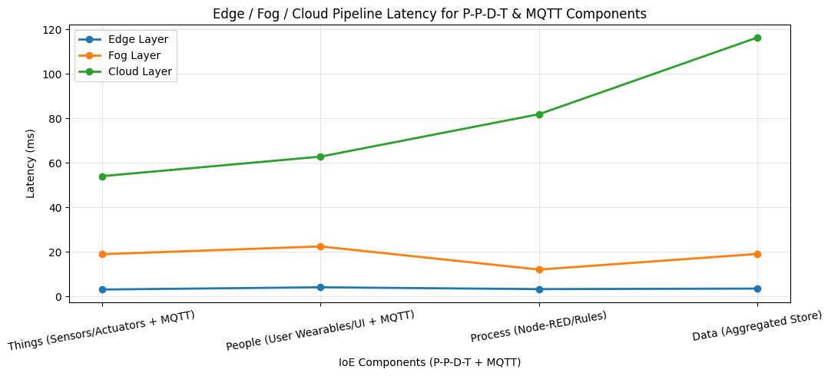
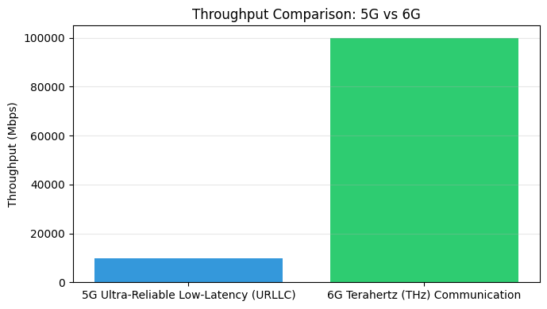
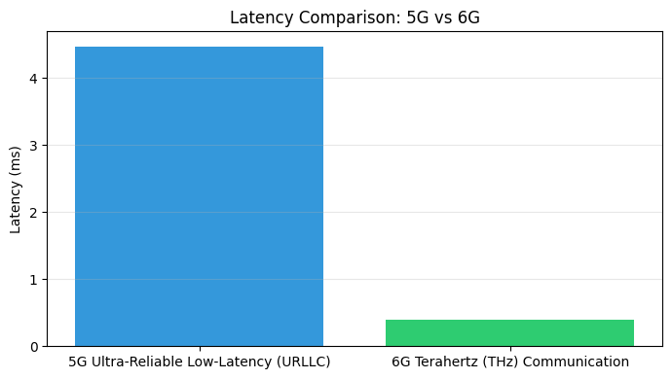
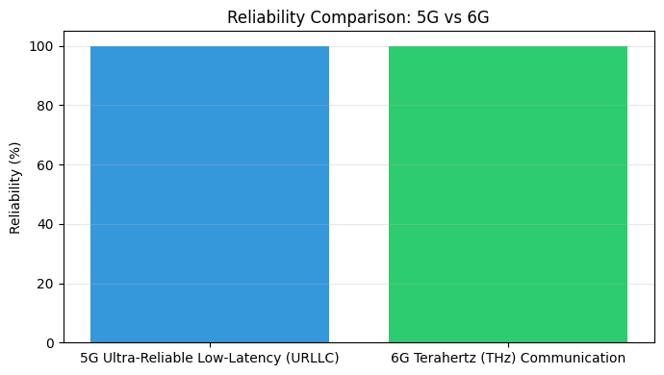
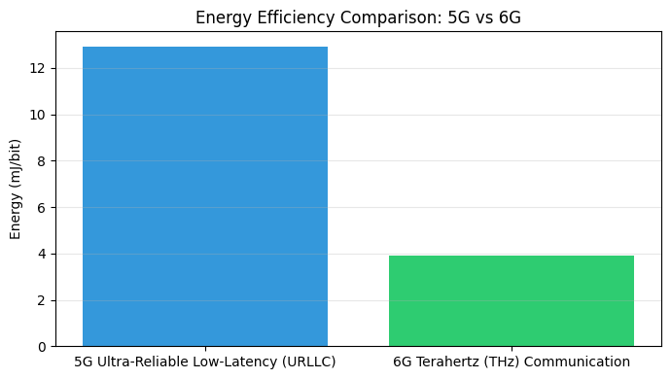

CONCLUSION & SUMMARY
1. Edge/Fog pipeline integrated with lightweight MQTT messaging minimizes local processing delay for Things and People components.
2. Cloud layer handles heavier aggregated P-P-D-T data storage with higher latency.
3. 6G significantly outperforms 5G in throughput, ultra-low latency (<1ms), and energy efficiency,
making it optimal for massive next-generation IoE deployments.

